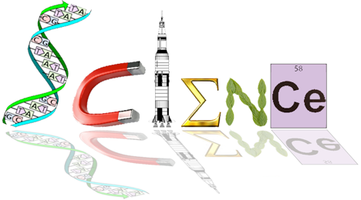

**Human Biology Year 12**

**ATHBY 2021**

**Task 9: Mutations and Gene Pools Test**

Weighting: 8%

**Multiple Choice Section: 20 marks**

**Answer all questions**

1. A Gene Pool is
   1. The variety of phenotypes in a population.
   2. The change in allele frequencies within a population
   3. The available genotypes within a population
   4. The movement of genes in and out of a population
2. Which of the following presents the best conditions for random genetic drift?
   1. Large population, migration, natural selection
   2. Small population, Natural selection, Migration
   3. Large Population, Random mating, No mutation
   4. Small population, No Natural selection, Random mating

1. A small island in the Pacific was studied and the population was found to carry an abnormally high frequency for the gene causing Achromatoplasia (absence of colour vision). Scientists concluded that this was due to **random genetic drift**.

Which of the following is the best example of how **random genetic drift** may have caused this result?

* 1. A cyclone struck the island suddenly. Most of the survivors carried the gene for Achromatoplasia
  2. The gene for Achromatoplasia gives a survival advantage to those who possess it
  3. Those who carry this gene are more likely to find mates and more likely to have children
  4. There has been a large growth of the population in recent years

1. People living in small island communities for a number of generations without significant immigration sometimes exhibit unusual levels of genetic diseases due to recessive mutations. This is due to:
   1. Founder effects from the original first settlers
   2. A diet lacking in essential antioxidants
   3. High levels of radiation causing mutations
   4. Elevated levels of genetic mutations accumulating in the population
2. Which of the following statements is/are correct?

i. Independent assortment of chromosomes during meiosis is one of the main sources of variation.

ii. Mutations are the only source of variation.

iii. Variation is greater within a reproductively isolated population than in one where

Interbreeding occurs with other groups.

* 1. i only.
  2. iii only.
  3. i and iii only.
  4. i, ii and iii.

1. Mutations to genes on the sex chromosomes are likely to be expressed
   1. equally in males and females
   2. more frequently in females
   3. more frequently in males
   4. not at all, because they are invariably lethal
2. Which of the following is true?
   1. Mutation causes major changes in allele frequency
   2. Mutations can only occur in one direction
   3. Mutation introduces new alleles into a population
   4. Mutation does not contribute to changes in allele frequency
3. The genetic disease known as Tay-Sachs has been the subject of much scientific debate over the evolutionary mechanisms that have produced the patterns of inheritance of the disease. Different theories, all of which have sound scientific reasoning, have linked Tay-Sachs to the founder effect, genetic drift and natural selection.

Which of the following would be the best reasoning to link the inheritance of Tay-Sachs to genetic drift?

* 1. The original populations carried a high incidence of the allele.
  2. Affected populations tend to be small and reproductively isolated.
  3. Sufferers of the disease reproduce at greater rates than non-sufferers.
  4. Carriers of the allele have a survival advantage over non-carriers.

1. Tay-Sachs disease is due to any of several mutant alleles. One possible explanation for its prevalence in Ashkenazi populations is that the alleles provide resistance to:
   1. sickle cell anaemia
   2. tuberculosis
   3. malaria
   4. a and c
2. DNA is ‘cut’ into pieces at pre-determined or recognition sites before it can be used in genetic engineering. The enzyme(s) used for this process is/are called
   1. DNA polymerase
   2. Restriction enzymes
   3. DNA ligase
   4. Primer enzymes

Use the following information to answer the next three questions: Q11, Q12 & Q13.

To clone a gene of interest, the following four steps are performed:

1. A plasmid is cut with a specific restriction enzyme.

2. The gene of interest is ligated into the plasmid.

3. Plasmids are transferred to bacteria.

4. Bacteria are grown on four nutrient agar plates (labelled W, X, Y and Z)   
 that are coated with or without ampicillin and arabinose.

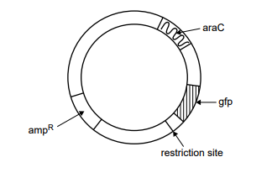An example of a plasmid used in cloning is shown below.

This plasmid contains a restriction site and the following three genes:

• ampR – confers resistance to the antibacterial agent ampicillin

• gfp – encodes the green fluorescent protein (GFP), which fluoresces under UV light

• araC – encodes a protein required to promote the expression of gfp when arabinose is present

The results from a bacterial transformation experiment are shown in the table below:

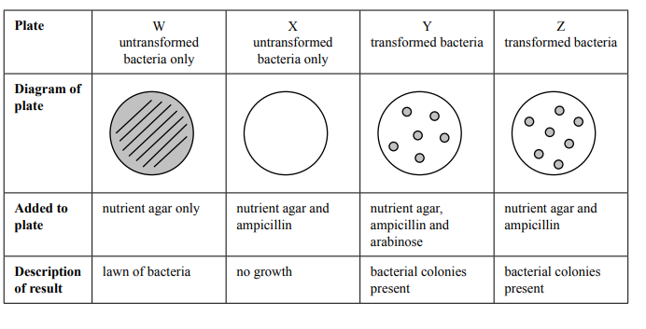

1. Bacteria are used in gene cloning because they:
   1. contain restriction enzymes that randomly cut chromosomes into fragments of varying size.
   2. can replicate non-bacterial sequences of DNA in a short time.
   3. replicate exponentially by undergoing mitotic divisions.
   4. allow the entry of foreign DNA into their nuclei.
2. Which plate would contain bacteria that fluoresce under UV light?   
   1. plate W
   2. plate X
   3. plate Y
   4. plate Z
3. Which one of the following statements is an accurate description for the purpose of plate W or X?   
   1. Plate W shows that the plasmid was cut with a restriction enzyme.
   2. Plate W shows that the percentage of transformed bacteria was high.
   3. Plate X shows that the nutrient agar promoted the growth of viable bacteria.
   4. Plate X shows that ampicillin was effective in killing the untransformed bacteria.
4. Vancomycin Resistant Enterococcus (VRE) is a significantly emerging, multi-resistant bacteria that can have devastating effects on immunocompromised hospital patients. Scientists wishing to discover how a susceptibility gene to the antibiotic vancomycin could be inserted into the wild population of the bacteria wished to use recombinant DNA technology.   
     
   Which of the below correctly describes how they would carry out the process for VRE?
   1. A susceptibility gene to clindamycin was inserted into a bacteriophage that was introduced into a culture medium containing a population of VRE. The bacteria were grown for 2 days in the medium, and then tested to see if they were still resistant to vancomycin.
   2. A susceptibility gene to vancomycin was inserted into a bacteriophage that was introduced into a culture medium containing a population of VRE. The bacteria were grown for 2 days in the medium, and then tested to see if they were still resistant to vancomycin.
   3. A susceptibility gene to clindamycin was amplified using PCR and then introduced into a culture medium containing a population of VRE. The bacteria were grown for 2 days in the medium, and then tested to see if they were still resistant to vancomycin.
   4. A susceptibility gene to vancomycin was inserted into some VRE cells in the laboratory. The bacteria were grown for 2 days in a medium, and then tested to see if they were still resistant to vancomycin.
5. . Which of the following statements describes speciation?
   1. A mutation occurs in an individual then produces a new species.
   2. Two different species interbreed to produce a different species with combined

features.

* 1. A population of one species diverges genetically and produces one or more new

species.

* 1. A small population can no longer interbreed with others in the larger population,

producing a new species.

1. Which of the following is a series of events that leads to the formation of two separate species?
   1. Variation, isolation, natural selection, speciation
   2. Natural selection, isolation, speciation, variation
   3. Isolation, variation, speciation, natural selection
   4. Variation, natural selection, isolation, speciation
2. The following statements relate to natural selection.

(i) Some genotypes provide a better chance of survival in specific environments.

(ii) Members of different species show some similarities in phenotype.

(iii) Some characteristics are heritable and are passed on to offspring.

(iv) Members of the same species show variation in phenotype.

Which of the statements support the theory of natural selection?

* 1. (i), (ii), (iv)
  2. (ii), (iv)
  3. (i), (iv)
  4. (i), (iii), (iv)

1. The term ‘selectively-advantageous mutation’ means the mutation
   1. provides a survival advantage in a particular environment.
   2. will always be passed to the offspring.
   3. is always changing to adapt to new environments.
   4. provides a benefit to heterozygote individuals in populations.
2. Which of these would NOT be considered a selective pressure in the environment
   1. Predators
   2. Infectious diseases
   3. Mutagens such as toxic chemicals
   4. all of the above are examples of selective pressures
3. Selective pressures in the environment act on:
   1. The phenotype of individuals, resulting in a decreased proportion of an advantageous allele in the population
   2. The genotype of individuals, resulting in an increased proportion of an advantageous allele in the population
   3. The genotype of individuals, resulting in a decreased proportion of a disadvantageous allele in the population
   4. The phenotype of individuals, resulting in an increased proportion of an advantageous allele in the population

**Short answer – 30 marks**

**Answer All Questions**

**Question 1 (4 marks)**

Describe two differences between somatic and germline mutations. (4 marks)

______________________________________________________________________________________________________________________________________________________________________________________________________________________________________________________________________________________________________________________________________________________________________________________________________

**Question 2 (8 marks)**

(a) People who have both alleles for the sickle-cell have the disease sickle-cell anaemia. What is sickle-cell anaemia? (2 marks)

______________________________________________________________________________________________________________________________________________________________________________________________________________________________________________________________________________________________________________________________________________________________________________________________________

(b) People who carry only one sickle-cell allele are said to have the sickle-cell trait. State one advantage and one disadvantage sickle-cell trait has for people with this condition. (2 marks)

______________________________________________________________________________________________________________________________________________________________________________________________________________________________________________________________________________________________________________________________________________________________________________________________________

(c) A different disease results from a different mutation in the same gene as sickle-cell anaemia. There are mild and severe forms of this disease, and symptoms can include anaemia and heart defects.

i) name the disease (1 mark)________________________________________________

ii) describe the mutations causing the disease, and how they differ in the mild and severe forms (3 marks)

______________________________________________________________________________________________________________________________________________________________________________________________________________________________________________________________________________________________________________________________________________________________________________________________________

**Question 3 (4 marks)**

Explain how the technique of gel electrophoresis separates DNA fragments of different sizes. (4 marks)

______________________________________________________________________________________________________________________________________________________________________________________________________________________________________________________________________________________________________________________________________________________________________________________________________

**Question 4 (4 marks)**

Consider the diagram below illustrating chromosomal mutations.

Label the following diagram in the boxes to name the different of mutations. (4 marks)

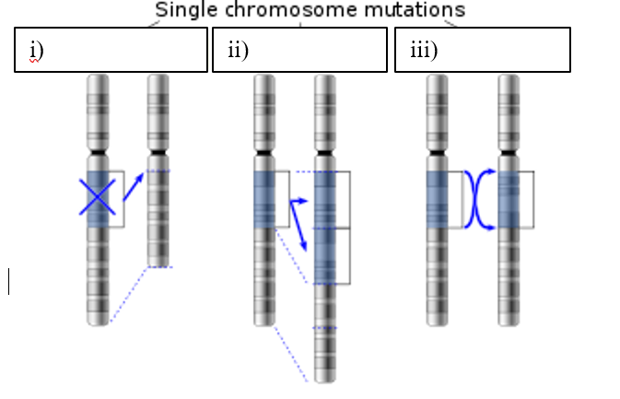

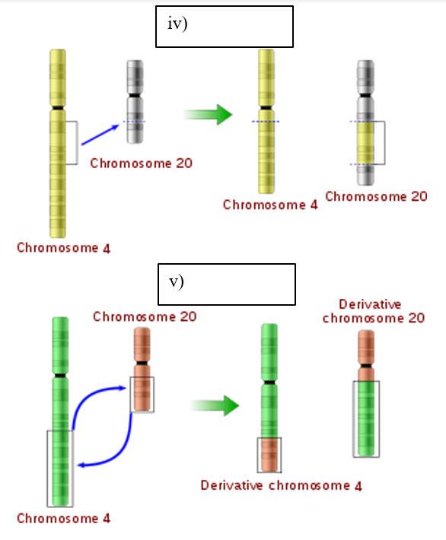

**Question 5 (10 marks)**

Huntington's disease is an autosomal dominant disease which does not appear until the sufferer is over 40 years old and leads to certain death within five to 10 years. The population of Afrikaner people in South Africa with Huntington’s disease is much higher than that in the general Dutch population. The Afrikaner population of South Africa is mainly descended from one shipload of Dutch immigrants which landed in 1652, which is believed to have carried a higher population of people with the allele for Huntington’s disease.

The above example involves two distinct populations. Define ‘population’. (1 mark)

____________________________________________________________________________________________________________________________________________________________

What is the cause of this difference in allele frequency between populations? (1 mark)

______________________________________________________________________________

Give three reasons from the situation above to support your answer. (3 marks)

______________________________________________________________________________________________________________________________________________________________________________________________________________________________________________________________________________________________________________________________________________________________________________________________________

Define gene flow (1 mark)

__________________________________________________________________________________________________________________________________________________________________________________________________________________________________________

Isolation prevents gene flow. Name the two most common barriers to gene flow and describe how they occur in the above example of South Africa during the 1700s. (4 marks)

____________________________________________________________________________________________________________________________________________________________________________________________________________________________________________________________________________________________________________________________________________________________________________________________________________________________________________________________________________________________________________________________________________________________________________________________________________________________________________________________________________________________________________________________________________________________________________________________________________

**Extended answer question 12 marks**

Lactose is the main carbohydrate in milk and is a major energy source for most young mammals. Therefore, the activity of the enzyme lactase is fundamental to the early development of most mammals, allowing them to break down and use lactose. After the weaning period is over, lactase production usually declines. However, many humans continue to express lactase throughout adult life, and are thus able to digest the lactose found in fresh milk. This trait is called lactase persistence.

1. Describe how a mutation in the lactase gene may have occurred. (4 marks)

__________________________________________________________________________________________________________________________________________________________________________________________________________________________________________________________________________________________________________________________________________________________________________________________________________________________________________________________________________________________________________________________________________________________________

B) There are different mutations which cause lactase persistence, but the most common one in European populations is a point mutation in the lactase gene.

Describe how point mutations occur and discuss the effects point mutations can have on protein expression. (8 marks)

________________________________________________________________________________________________________________________________________________________________________________________________________________________________________________________________________________________________________________________________________________________________________________________________________________________________________________________________________________________________________________________________________________________________________________________________________________________________________________________________________________________________________________________________________________________________________________________________________________________________________________________________________________________________________________________________________________________________________________________________________________________________________________________________________________________________________________________________________________________________________________________________________________________________________________________________________________________________